Report

on

Optional Individual Submission 5: Extra-Credit/Bonus

Completed Coursera Courses:

1. Cloud Computing Basics (Cloud 101)
2. Cloud Computing Fundamentals on Alibaba Cloud

Course Code: CSE707

Course Title: Distributed Computing Systems

**Prepared For**

**Annajiat Alim Rasel**

**Prepared By**

**Sohel Rana**

**ID: 20366015**

**Program: M.Sc. In CSE**

**Department of Computer Science and Engineering**

­­  **Brac University**

Course-1: Cloud Computing Basics (Cloud 101)

Coursera Account Email: [rana.rina08@gmail.com](mailto:rana.rina08@gmail.com)

Coursera Account Name: Sohel Rana

Proof: I have studied all the chapter of the selected course but not getting the certificate due to pending the module Quiz only that can’t be possible for the audit course. For the proof attached necessary screenshot in below.

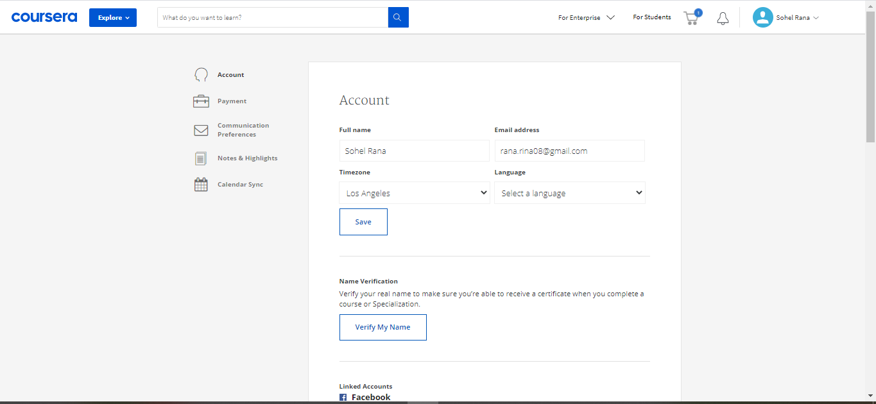

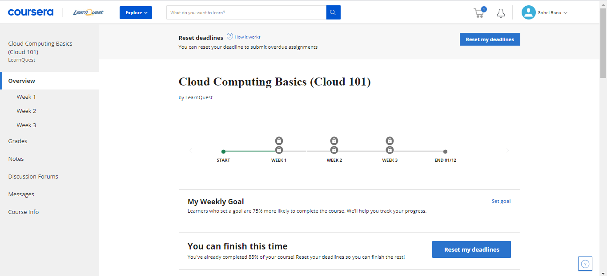

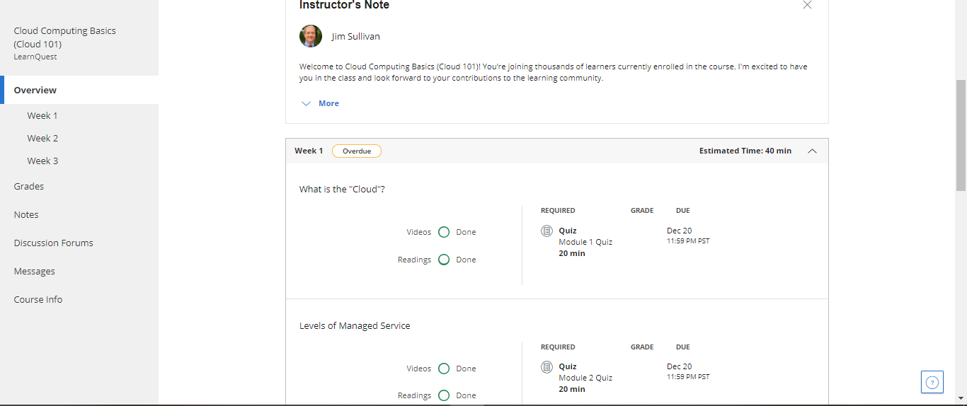

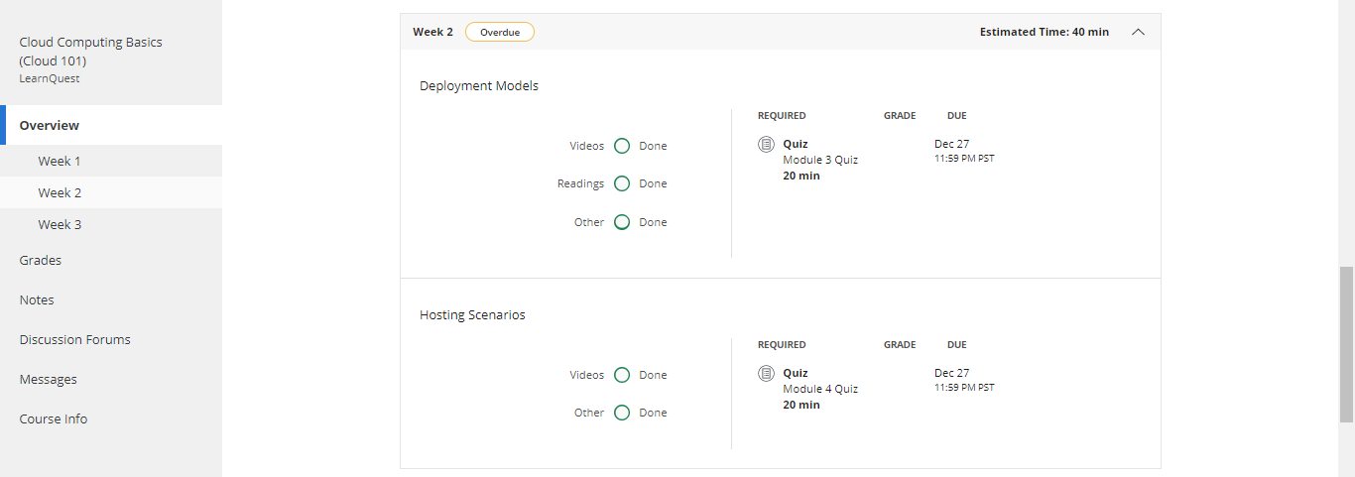

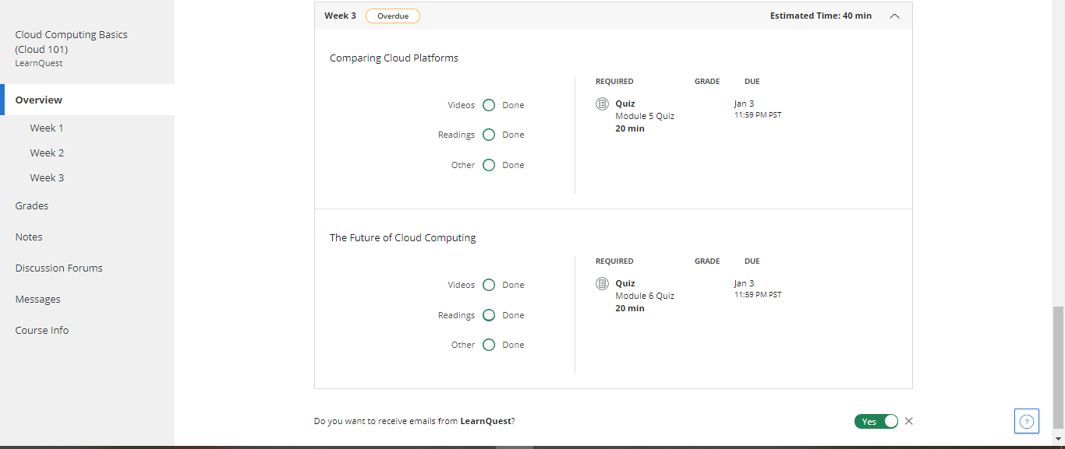

**Course-1: Cloud Computing Basics (Cloud 101)**

**Summary**: Cloud computing is the availability of computing resources and services over the internet. In other words, cloud computing allows you to use resources and services online instead of having to build and maintain the infrastructures necessary. Cloud computing has many benefits. For one, it works on a pay-for-use basis. This means that you only pay for resources that you are using and only spend exactly as much as you need, not a penny more. Secondly, something that is very appealing is the elasticity of the resources. You can increase or decrease your usage any time you want depending of your need of that resource. A third aspect of cloud computing is that services previously provided by IT administrators will be accessible to any user at any time. Cloud computing allows users to store files online which would be accessible from any device and from anywhere. This feature is useful for individual users as well as large scale companies. In the case of large amounts of data, companies would only pay for storage they are taking up without having to maintain the physical infrastructure needed to store that data. Cloud computing manually backing up data, especially in large amounts, can be very tedious. Furthermore, it is prone to errors and malfunctions which would make this practice very unreliable. Limited space and time consumption were some of the main factors for which manual data backup was abandoned. Cloud computing makes this process automatic and free of human error. In addition to that, the issue of running out of space isn’t one anymore and neither are the security and the availability of the data.

Course-2: Cloud Computing Fundamentals on Alibaba Cloud

Coursera Account Email: [rana.rina08@gmail.com](mailto:rana.rina08@gmail.com)

Coursera Account Name: Sohel Rana

Proof: I have studied all the chapter of the selected course but not getting the certificate due to pending the module Quiz only that can’t be possible for the audit course. For the proof attached necessary screenshot in below.

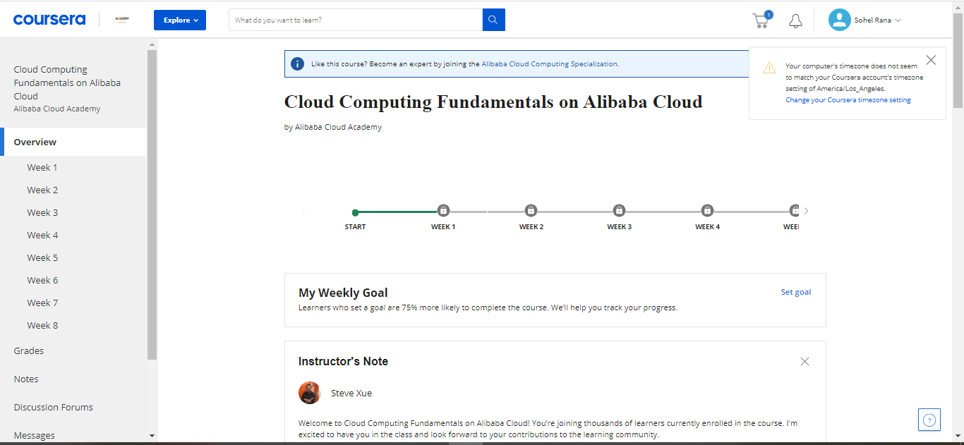

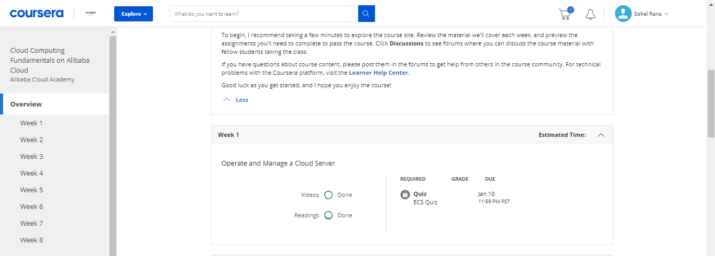

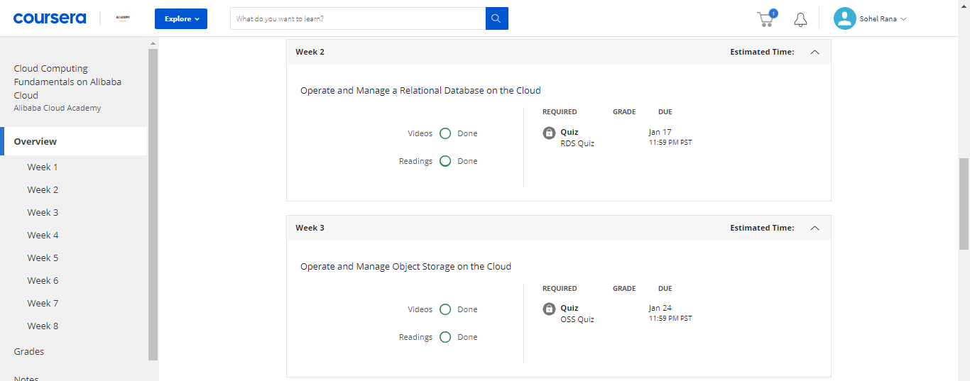

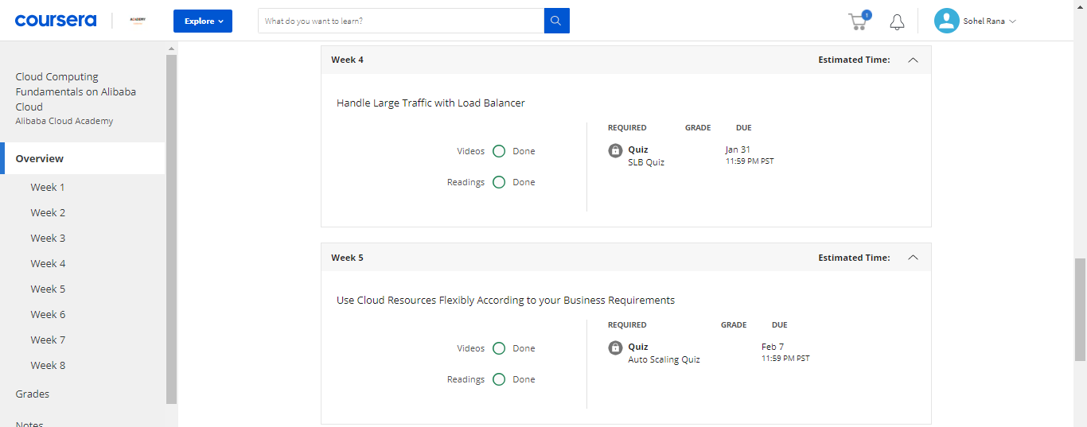

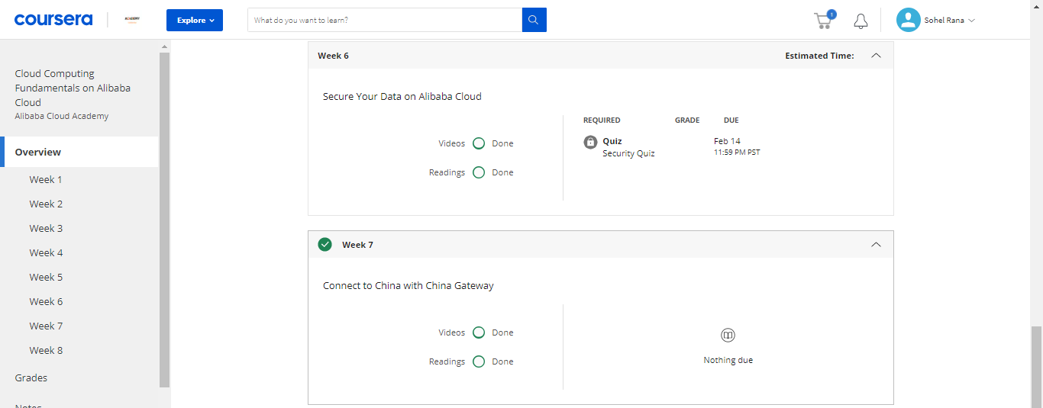

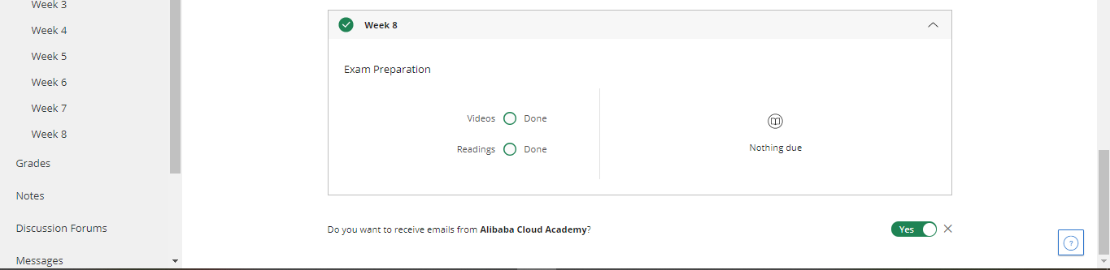

**Course-2: Cloud Computing Fundamentals on Alibaba Cloud**

**Summary**: Alibaba Cloud provides cloud computing IaaS, PaaS, DBaaS and SaaS, including services such as e-commerce, big data, Database, IoT, Object storage (OOS), Kubernetes and data customization which can be managed from Alibaba web page or using aliyun command line tool. Alibaba Cloud with a comprehensive introduction to the range of products and solutions offered by Alibaba Cloud. Fundamental Architecting on Alibaba Cloud is designed for users looking to start this journey with a look into Alibaba Cloud's core products. Fundamental Architecting investigates storage, networking, auto-scaling, and security solutions as well as scenarios to best combine these products to create a complete cloud-based architecture. Understand the advantages of a cloud server and learn how to purchase an ECS on Alibaba Cloud, manage the server on our console, backup critical data and ensure system can adjust according to business needs. The basic concepts of RDS, the benefits of using compared to conventional database solutions and understand the key features. It’s introduced database/account management, security settings, read-only instances, database backups, and third-party tool integration.

The basic concepts of OSS include demos such as bucket management, object storage operations, image processing, website hosting and monitoring and introduces the OSS related security features. Load balancing lies in "sharing." When massive traffic is detected, the traffic is distributed to multiple servers to improve the external service capability of the website and avoid the impact of a single point failure. The basics of load balancing, principles and scenarios, and master cloud platform load balancing features and usage. Use Cloud Resources Flexibly According to your Business Requirements

-This module helps students familiarize themselves with the basic functions and characteristics of Alibaba cloud auto-scaling, learn the basic operations and how to use auto-scaling to achieve the flexible architecture design of the platform, and how to automatically adjust the flexible computing resources according to business needs and strategies. We have understand where data should be secured on Alibaba Cloud, such as storage technology, backup, recovery solutions, how to transmit data securely, which encryption algorithm to choose, and so on as part of core skills of data security protection on Alibaba Cloud platform, including how to implement automatic remote backup of data, how to implement encrypted storage in a cloud environment, and how to generate SSL certificate. Alibaba Cloud provides to users looking to connect their network or business to China through leased line connections and private networks.